MILESTONE 1 REPORT

Data Preparation & Environment Setup

Objective
The objective of Milestone 1 was to design the overall system architecture and prepare the dataset required for training the PPE detection model. This phase focused on setting up the development environment and organizing data in a format suitable for YOLOv8 training.

Work Done

1. Requirement Analysis
- Defined project goals: detect PPE compliance and safety violations.
- Identified rules such as:
  - Missing helmet → violation
  - Missing safety vest → violation

2. Dataset Collection
- Downloaded Construction Site Safety Dataset from Kaggle.
- Dataset contains images of:
  - Workers with PPE
  - Workers without PPE

3. Data Preprocessing
- Converted dataset into YOLO format:
images/
train/
val/
test/
labels/
train/
val/
test/
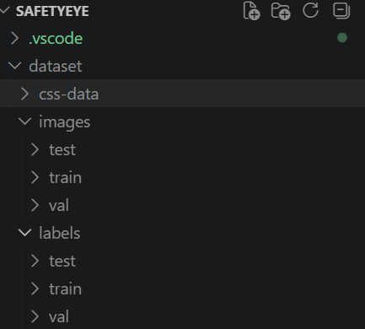
- Each label file contains:
class_id x_center y_center width height

4. Dataset Splitting
- Training set → model learning
- Validation set → tuning
- Test set → evaluation

5. Environment Setup
- Installed:
  - Python
  - PyTorch
  - Ultralytics (YOLOv8)
  - OpenCV

Deliverables
- Organized dataset in YOLO format
- Config file (data.yaml)
- Working development environment

Outcome
A properly structured dataset and environment were created, enabling efficient training of the object detection model.

